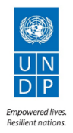
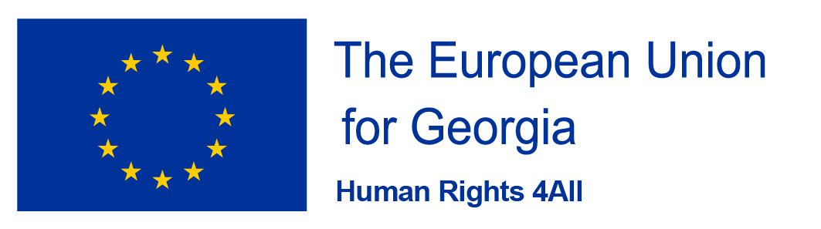

UNDP Expert Peyman Pejman’s Workshop on Communication
Group I - 17-18 December 2018; Group II - 19-20 December 2018.
Lopota Hotel, Georgia

Day I

10:00-10:15 | Welcome Remarks:  - Natalia Jaliashvili  - UNDP Representative (TBC)  - Peyman Pejman
10:15-10:45 | The need for revisiting communications on human rights; communications terminology
11:45 – 13:00 | Review of how ministries portray communications on their websites
13:00 – 14:00 | Lunch break
14:00 – 15:30 | How ministries can individually improve communications  Using just news-related events  Using Outreach activities
15:30 – 15:45 | Coffee break
15:45 – 17:00 | How and why you should also do multilateral communications (intra-ministries)
17-00 – 18:00 | How to increase exposure using the media

Day 2

10:00 – 11:00 | Discussion, Q&A about the previous day’s presentations
11:00 – 12:00 | Dividing the group into individual ministries for an exercise on how each ministry can create and implement a communications activities. Time allowing, each ministry will give a short presentation. Participant can take individual break breaks while they work together
12:00 – 13:00 | Afternoon Session: Presentations by as many groups as time allows
13:00 – 14:00 | Lunch Break
14:00 – 15:30 | Participants working as one team to choose a topic and a communications plan on a human rights-related topic
15:30 – 15:45 | Coffee break
15:45 – 17:00 | Group presentation
17:00 – 18:00 | Final discussion, questions

Simulations translation will be provided

